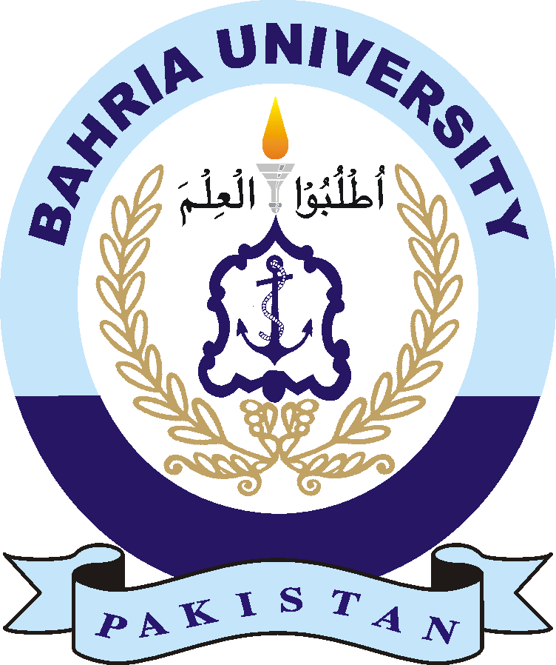

**BAHRIA UNIVERSITY (KARACHI CAMPUS**)

SPRING SEMESTER – 2023

(COURSE TITLE: Linear Algebra COURSE CODE**: (GSC-121)**

Class: **(BS (SE) - 2A/2B/2C,)** Quiz # 1

Course: Instructor: **(Muhammad Imran)** Time Allowed: **0.5 Hours**

Max Marks: 0**5** Student’s Name: __________________

|  |
| --- |
| **Q1: - Find the solution of the given homogeneous system of equation and Write their solution in parametric vector form. $x_{1}-$**  **3 $x_{2}$ + 2 $x_{3}+2x_{4}=0$ $-x_{1}+x_{2}+3x_{3}-x_{4} =0$ ${3x}_{1}-{9x}_{2}-6x_{3}+6x_{4}=0$**      **Q2: - For what values of “h” the given three planes have at least**  **One point of intersection. $2x_{1}+$**  **4 $x_{2}$ + 4 $x_{3}$ $=4$ $x_{2}-2x_{3}=-2$ ${2x}_{1}+3x_{2}+2hx_{3}=0$** |
|  |
|  |